Relax Technologies Take Home Writeup

*For the completed Jupyter Notebook with step-by-step, click here*

**Executive Summary**

A Random Forest Classifier model was the final model considered with an accuracy rating of 86.6% since this is an appropriate model for a binary classification problem.

In terms of features the Relax can actually influence (listed below), we found statistically significant but not particularly substantial predictive power features to make predictions on:

* Did the user create a least one session? (*session_created)*
* Did the user enable marketing drip (*enabled_for_marketing_drip)*
* Did the user opt into the mailing list (*opted_in_to_mailing_list)*
* Was the user invited by another user (*invited)*

However, we did find that certain organizations (identified by organizational ID) do have higher rates of adopted users which identifies one possible avenue for Relax to consider. Relax may benefit from focusing on organization with higher adoption rates regarded targeted marketing. This may allow them to better utilize their marketing budget for higher returns on generating adopted users.

**Notes of Concern & Recommendations**

Two main concerns arose while conducting this analysis that would be potentially useful to consider. First, the predictive model generally tried to stay to features that Relax could actually act upon, make logical sense to consider, or were dense enough to warrant. Therefore, features like *creation_time* or *invited_by_user_id* were either not used or modified to be better suited for modeling. This did not leave many features to work with and may be a consideration for Relax in that they don’t have many “levers” as it currently stands according to the data to try and influence whether a user becomes an adopted user. As such, Relax may want to consider what further methods they can employ to make more users adopted users.

Second, the low adopted user rate out of the total users provided (only 13.8% of all users are adopted users based on the metric[1] provided by Relax) does suggest Relax may benefit from a “deeper dive” into its current adopted users. Currently, there are not many adopted users to really explore to begin with from a raw data standpoint. This may mean that it would be beneficial for Relax to do some more qualitative analyses (e.g., focus groups, customer interviews, etc.) to garner more information from these uses to understand more about what may make them likely to become adopted users, which in turn may provide useful leads regarding identifying new features that can be tracked (or generated) to help develop more predictive power for models.

Appendix – Tables and Figures

*Table 1: Account Creation Pathway Versus % of Adopted Users*



We can see that how the user creates their account does not seem to have much predictive power regarding whether a user will eventually become an adopted user or note

*Table 2: Opt Into Mailing List Versus % of Adopted Users*



We can see here that there doesn’t appear to be an easily discernable difference between whether a user opts into the mailing list and whether they ultimately become an adopted user

*Table 3: Enabled For Marketing Drip Versus % of Adopted Users*

Once again we can see not to strong of an indicator regarding a user becoming adopted but it is at least slightly more predictive than some of the other features.

*Table 4: Invited By Another User Versus % of Adopted Users*



We can see hardly any difference between someone being invited by another user and whether they become an adopted user

*Figure 1: Feature Importance From Random Classifier Model*

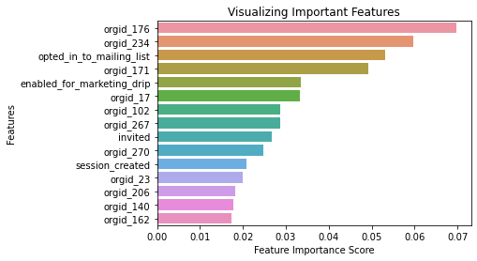

This figure shares the importance of the top 15 features from the Random Classifier Model. You can see that the four features we highlighted are on the figure. However, one important observation is that many of the organizational IDs make it into the top 15 (some above the other features) which may mean that it can make sense for Relax to initial target those organization regarding getting higher adopted user rates. For example, *Organization 176* has the strongest predictive power of all the other features so it may make sense for Relax to initially explore who that organization has a higher adopted user rate than most other organizations.

1. Defining an "adopted user" as a user who has logged into the product on three separate days in at least one seven day period